17.78: The radius is found from

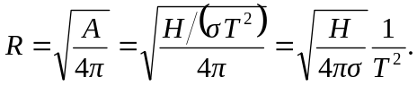

Using the numerical values, the radius for parts (a ) and (b ) are

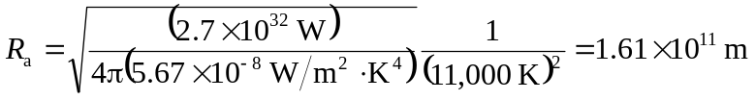

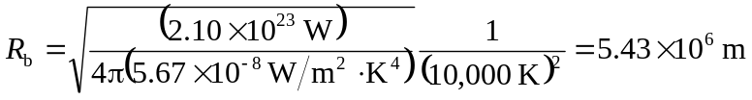

c) The radius of Procyon B is comparable to that of the earth, and the radius of Rigel is comparable to the earth-sun distance.

